

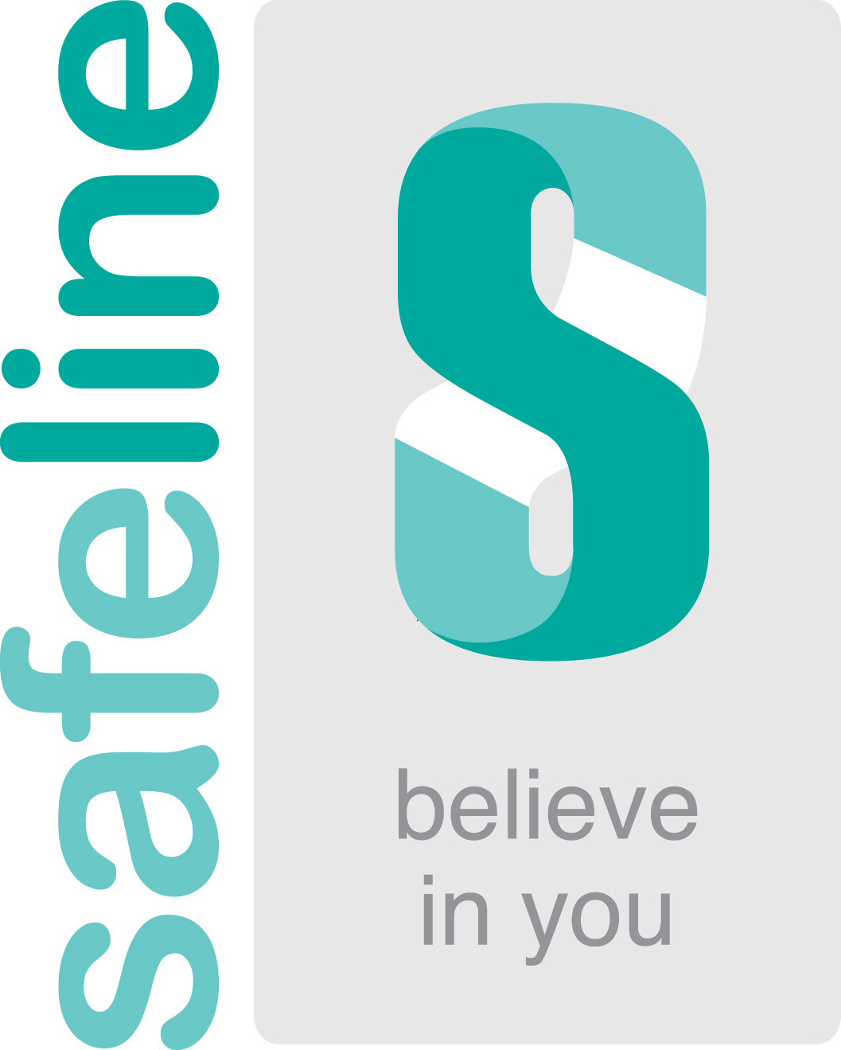

SAFELINE FREE WILL SCHEME
October 2022

We are proud to commit our time and efforts to Safeline this year.

This is a real commitment by the team at Alsters Kelley Solicitors, both in respect of our time and our expertise whilst raising funds for a very worthy cause.

We wanted to make it as clear as possible up front as to how the Scheme will work to enable us to deal with the matter as efficiently as possible.

Under the Safeline Scheme, we will draw up for you a basic Will, free of charge. Instead we will expect that you will make a voluntary contribution to Safeline. The suggested donation level at present is £100 for a basic single Will or £180 for basic mirror Wills. (Our usual fee for a basic single Will is £165 plus VAT or £300 plus VAT for basic mirror Wills). The donation can be made online on the Safeline Website or alternatively, you can leave a donation in your Will to them.

It is important that you help us by completing the Will Questionnaire enclosed with this voucher as best as you can, prior to the appointment. If you require further copies, please let us know. It would be helpful if you are able to send this back to us prior to your meeting. At your initial appointment, you will be required to bring identification evidence, which should consist of two forms of identity, the first being photographic ID such as a passport or driving licence, the second being confirmation of your home address on a recent utility bill or bank statement.

Finally, the Scheme only works for the drawing up of a basic Will for clients. There may be, and are often occasions, where we need to charge an additional fee for additional advice or services.

A Basic Will covers some of the following circumstances and provisions:

- The appointment of Executors and substitutional Executors.
- A straightforward bequest of personal items to be distributed in accordance with any Letter of Wishes.
- Up to half a dozen bequests of set sums of money, known as legacies.
- Leaving your residuary estate to your spouse or partner with substitutional provisions for children or a division of your estate amongst other individuals or charities.
- A simple statement in respect of your funeral wishes.

Some aspects of Will drafting do introduce certain complexities which are not covered by a basic Will under the Safeline Scheme and we will advise you of any additional charges in respect of this in advance. This can cover aspects such as:

- Advice and assistance in respect of dealing with foreign assets.
- Specific Inheritance Tax advice.
- Advice on inclusion of guardianship provisions and the inter-relation between the Guardians and the Executors and Trustees.
- Any Trust advice or the drafting of Trusts within the Will for protective, tax or succession purposes.
- Dealing with any specific property bequests.
- Advising and dealing with business or agricultural assets.
- Advice and assistance in respect of other matters such as Care Home fees, asset protection, Powers of Attorney or Living Wills.

The purpose of this information is to be absolutely clear and upfront as to where further charges may arise and to enable you to understand this. You can enquire if particular aspects you would like to cover in your instruction may be outside the scope of a Basic Will and this enables us then to provide you with an estimate of any additional likely costs for advising you and helping you in respect of these matters.

We look forward to helping you to put in place a Will under the Safeline Scheme this year and hopefully to be a valued client in the future.

CONTACT:

Britanie Jeffery – Legal Secretary in Private Client
Telephone number: 01926 356042
Email: britanie.jeffery@alsterskelley.com

If you need any further information about matters in this information sheet then please do not hesitate to contact us.

