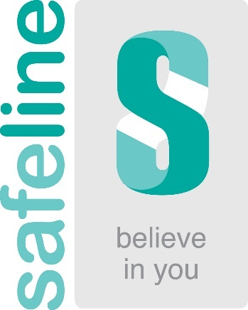
Information for Male Survivors of Sexual Abuse

It is estimated that 1 in 6 males have suffered some form of sexual abuse in their lives. If you’re one of them, then know from us that you’re not alone.

Established in 1994 to serve survivors of sexual abuse, Safeline provides a safe environment for people to talk about their experiences. Our services for male survivors have been independently accredited.

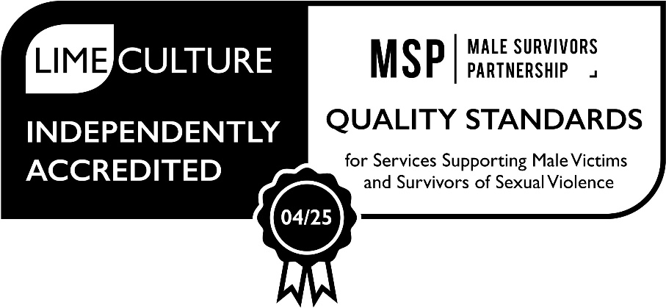

We understand how difficult it can be sometimes to talk about your experiences or to know how to find the words and to seek support. You may have felt guilty or ashamed and blamed yourself for what happened. We can help people make sense of their thoughts, feelings and behaviours and understand why they may be feeling the way they do.

Getting support can be an essential part of your healing. With support it is possible to gain the power and control over the impact of abuse.

Our team of friendly professional staff have all undertaken accredited training to work with survivors of sexual abuse and will give you the space you need to go at your pace when you feel ready to talk. We provide emotional support, guidance, and information. We’ll try to make it as easy as possible for you to take that first step in asking for support.

“Stop asking yourself if it’s worth doing, just do it, you are not alone.” Quote from a male Safeline counselling client.

Services available to males

Counselling: If you live in Warwickshire or Coventry, you can access free Specialist Face-to-Face Counselling by simply contacting us on 01926 402498 or emailing us on warwickshirecounselling@safeline.org.uk to refer into the service. You can request to see a male or female counsellor.

Safeline also offers Telephone and Online Counselling to people in England & Wales who have been affected by Childhood Sexual Abuse and are aged 16+. To find out more: Telephone & Online Counselling - Safeline - Believe in you - Surviving sexual abuse & rape

Emotional Support: You can also call the National Male Survivors Helpline and speak confidentially to a trained member of staff for emotional support on 0808 800 5005. The helpline is free and is open Mon-Fri: 9am-8pm and Saturday and Sunday: 10am-2pm. Or you can use our Text Support Service: 07860 065187.

Or click on the link below and then the ‘Live Chat’ icon to access the Male Survivor Live Chat Service: National Male Survivor Helpline and Online Support Service - Safeline - Believe in you - Surviving sexual abuse & rape

Advocacy: Our Independent Sexual Abuse Advocates can make sure you have the best possible advice, information, access to services and support that you need and can act as an advocate for you when dealing with other agencies. If you are considering reporting to the police, they can also provide advice and support throughout the Criminal Justice process. Contact us at the office on 01926 402498 or email ISVA@safeline.org.uk to ask for advocacy.

You can access all or any of these service and so can those people who are supporting you.

Visit the Safeline Website at https://safeline.org.uk/ to find out more about Safeline and the services it offers males who have experienced sexual abuse.

