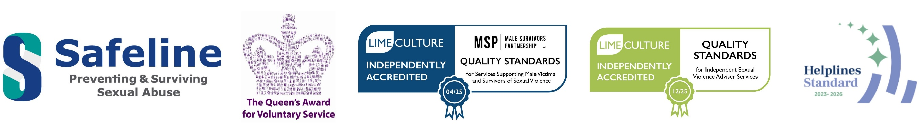
Operations Assistant

This is a full-time position working 5 days a week (37.5 hours), Monday to Friday 9am to 5pm.
Salary Package: £25,500 per annum
Location: Safeline is based in Warwick Town Centre. Hybrid home and office working where effective service delivery allows.
25 days paid holiday + public holidays + a birthday concessionary day. Incremental annual leave with length of service.
Matched contribution pension scheme up to 5% of gross salary.

Safeline is a Warwickshire based, leading specialist sexual abuse and rape charity. We help women, men and young people who have been abused to rebuild their lives, we protect those at risk, and we find ways to prevent abuse from ever happening. We have been protecting and supporting people affected by sexual abuse and rape since 1994 and we intend to continue this vital work for many years to come because the need for organisations like ours has never been greater.
We have an exciting opportunity to join our friendly team as an Operations Assistant. As a member of the Operations Department, this role will support Safeline and the Head of Operational Services in the delivery of its day-to-day operational activity, ensuring the efficient, safe, and legal functioning of the organisation through a range of administrative, financial and practical tasks to enable Safeline to fulfil its aims and objectives. This role can be varied with tasks including book-keeping responsibilities, data collation, supporting Safeline with its HR needs, being a health and safely lead representative and supporting with Safeline premises and infrastructure needs.
The successful candidate will have previous financial, book-keeping experience and of working in an administration setting. They will be able to demonstrate their ability to work within the boundaries of strict confidentiality and discretion, display good organisational skills, have high attention to detail, have the ability to prioritise tasks as well as being able to consistently work to deadlines. They will report directly to the Head of Operational Services.
Suitably qualified individuals interested in the role should contact Safeline via email office@Safeline.org.uk for a full Job Description and Application Form. CVs will not be accepted.
The closing date for applications is 9am Monday 10th February 2025.
Safeline is committed to the Safeguarding of young people and vulnerable adults and adopts strict measures to ensure the safety of its clients. Safeline expects all staff to work within its safeguarding policies and procedures. Safeline is committed to promoting a diverse and inclusive community and encourages applications from all genders, ethnicities and cultures.
.
