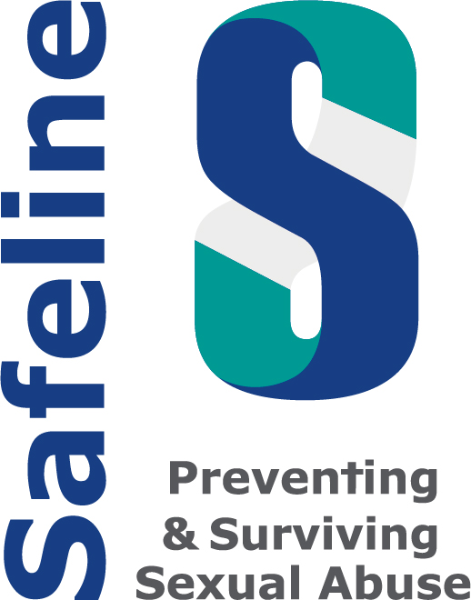
ISVA SELF REFERRAL FORM
FIRST NAME | LAST NAME | DATE OF BIRTH | TODAY’S DATE

ADDRESS |  | IS IT OK TO CONTACT YOU BY POST?
EMAIL |  | IS IT OK TO CONTACT YOU BY EMAIL?
PHONE NUMBER | IS IT OK TO PHONE THIS NUMBER? | IS IT OK TO LEAVE A VOICEMAIL OR TEXT MESSAGE?
WHAT IS YOUR PREFERRED METHOD OF CONTACT? (EMAIL/PHONE/POST) | WHERE DID YOU HEAR ABOUT SAFELINE? | COMPLETED BY (NAME)

Please supply a brief reason for why you are looking to access the Safeline ISVA service?

If you have already reported a crime and have the information, please provide details of the officer in charge of the case and the crime reference number

Do you currently have any other agencies or services involved in your care? | Please note any disabilities you may have - Physical, Learning, Mental Health etc.

Are you able to attend an initial assessment in Warwick? Y/N
Are you able to climb stairs? Y/N
If applicable is the person accompanying you able to climb the stairs? Y/N
Preferred days/times for initial assessment? (Monday-Friday between 9am and 4pm)

By submitting this form, you are giving consent to Safeline to store and process your personal information in line with the General Data Protection Regulation (GDPR) of the Data Protection Act 2018.

Additional information for funding purposes only - if you would prefer not to say then please leave blank
GENDER: | SEXUALITY: | ETHNICITY:
PLEASE RETURN TO ISVA@safeline.org.uk or via post to Safeline, 6A New Street, Warwick, CV34 4RX

